--=================================================================================
--===============================CIS 310 ASSIGNMENT 1===============================
--=================================================================================
/* Fill in below section with your name, ID, and submission date. Also, update file name to reflect YOUR first and last name.
STUDENT NAME: Dylan Shea
STUDENT ID: 5505131
SUBMISSION DATE: 1/11/2024
*/
1. What 2 businesses/organizations will you use for your learning examples? (10 points)
-- You should name the businesses/organizations and write a brief summary of business, what’s its business model, what type of data is generated in its business operations, etc. Ideal summary is 2-5 sentences. It does not have to be exhaustive or perfectly correct but should demonstrate that you have an understanding of the business and some basic data they store.
e.g. Tiny College. Tiny college is a non-profit higher education organization, whose main business function is offering education as a service to students. Through the college’s daily operations, we gather and store data on the college’s customers: students, their courses, schedules, grades, etc. We also keep tracks of employee data, consisting of professors who teach the classes, and administrators such as librarians, support staff and advisors. Physical building, IT support and equipment such as computers inventory are also information we need to keep track of.
-- Note that these are not set in stone and can be reviewed/changed as the semester progresses.
-- Learning database theories with specific business contexts and example in mind helps deepen your understanding of these challenging concepts.
-- In class, we will use Tiny College as our model business, therefore, colleges/higher ed cannot be one of your choices.
For my 2 examples I will use a retail store, such as Target, and any random Real Estate Firm.
For the retail store, they have to keep track of a lot of items that would be included in a database. On the customer side, they keep track of purchases made by customers, the cashiers and other employees that help that process, like stocking or greeting, pay those employees and a lot more. In the inventory-side, you have to keep track of the stock for every single product, on top of the employees who stock them. You also have to track the manufacturers and distributors that give you those products.

For the real estate firm, it ends up being a lot simpler. You keep track of each agent and all their clients, including phone numbers and current addresses for both agent and client. You also have to keep a record of all available houses and the amount of times each client has met with the agent, and their standing on the house buying process.

2. What are 4 of DBMS's advantages over traditional File System Data Storage methods? (5 points)
--You should name the advantages and write a brief explanation, 1-2 sentences each, on its meaning using examples. You are encouraged to use the business/organization of your choice from 1 to walk through these explanations in context.
--This should NOT be a copy and paste from textbook or any other sources.
A file system is not as effective as a DBMS because it takes longer to organize and set up, and not all information is always in the same place, imagine trying to organize all departments of a Target through individual files.
File systems also don’t allow easy sharing across computers or desks.
DBMS also allow “Find in Page” allowing real estate companies to find specific details about customers.
DBMS also back themselves up in case of emergency, while physical or technical copies of files don’t always do that.

3. The textbook lists of database related career opportunities. Out of these options and other analyst positions (financial/marketing etc…), which one are you most interested in? According to Google, LinkedIn or other sources, what's the salary for that position in Kentucky (or wherever you are located)? (5 points)
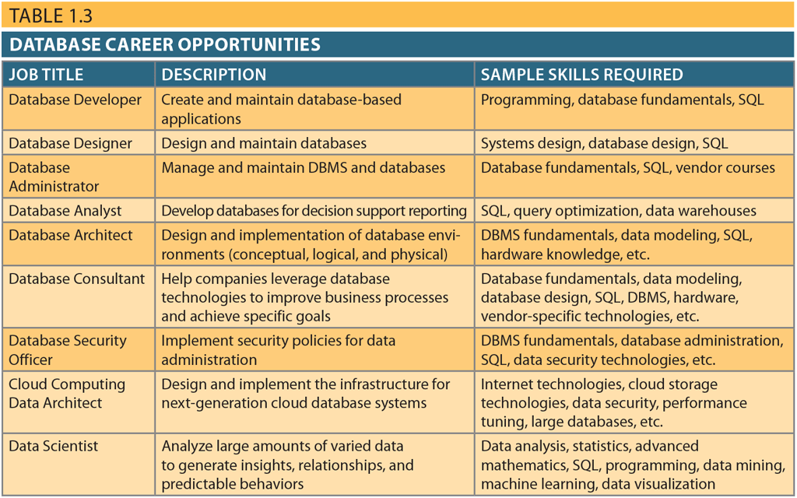

I would like to become a Data Scientist in a marketing/sports scouting field. I enjoy study trends that produce success in customer purchasing. Data Scientists in Louisville make approximately 133k, while marketing analysts make about 55k

4. What does your success in CIS 310 Database Design look like? (5 points)
-- This is entirely up to and unique to you. Ideal response are 1-2 sentences.
Feeling comfortable with database design and SQL to work a Co-op or internship after completing this course.

5. Anything else I should know about you? (5 points)
--This is open ended, feel free to share what you’d like. Your major, your interests, interesting facts, or anything important you’d like me to know. Most responses are 3-5 sentences, however, the length is entirely up to you.
I’m a CIS Major with the track in Data Analytics, and I believe this is my 3rd semester as a CIS Major. I’m currently a sophomore from Detroit, Michigan.

